Experiment No: Q53
Title
Maximum Square Submatrix of 1s Using Dynamic Programming

Aim
To find the size of the largest square submatrix consisting entirely of 1s in a given binary matrix using Dynamic Programming.

Theory
A square submatrix is a smaller square-shaped matrix formed from a larger matrix. In this problem, we need to determine the largest square submatrix that contains only 1s.
Dynamic Programming is used to efficiently solve this problem by storing the size of the largest square ending at each cell.
For a cell (i, j) containing 1:
$$DP[i][j]=1+min⁡(DP[i-1][j],DP[i][j-1],DP[i-1][j-1])$$
If the cell contains 0:
$$DP[i][j]=0$$
The maximum value in the DP table gives the size of the largest square submatrix.

Algorithm
- Read the dimensions n and m.
- Input the binary matrix.
- Create a DP table of size n × m.
- Copy the first row and first column values from the original matrix.
- For each remaining cell:
  - If the cell contains 1, compute:
DP[i][j] = 1 + min(
DP[i-1][j],
DP[i][j-1],
DP[i-1][j-1]
)
  - Otherwise, set DP[i][j] = 0.
- Track the maximum value in the DP table.
- Display the maximum value as the size of the largest square submatrix.

Program
# Maximum Square Submatrix of 1s using Dynamic Programming
def largest_square(matrix, n, m):
dp = [[0 for _ in range(m)] for _ in range(n)]
max_size = 0
for i in range(n):
for j in range(m):
if i == 0 or j == 0:
dp[i][j] = matrix[i][j]
elif matrix[i][j] == 1:
dp[i][j] = 1 + min(
dp[i - 1][j],
dp[i][j - 1],
dp[i - 1][j - 1]
)
else:
dp[i][j] = 0
max_size = max(max_size, dp[i][j])
return max_size
n = int(input("Enter number of rows: "))
m = int(input("Enter number of columns: "))
print("Enter the binary matrix:")
matrix = []
for i in range(n):
row = list(map(int, input().split()))
matrix.append(row)
size = largest_square(matrix, n, m)
print("\nSize =", size)

Sample Input
Enter number of rows: 3
Enter number of columns: 4
Enter the binary matrix:
0 1 1 0
1 1 1 1
1 1 1 1

Output
Size = 2
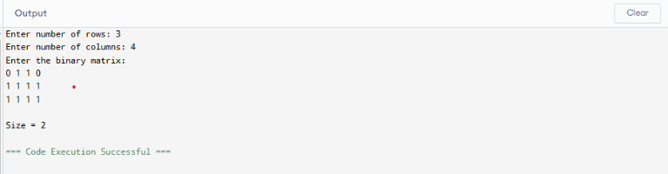

Observation
Input Matrix
0 1 1 0
1 1 1 1
1 1 1 1
Largest Square Submatrix
1 1 1
1 1 1
1 1 1
Size
3

Analysis
- Dynamic Programming stores intermediate results and avoids repeated calculations.
- Each cell is processed exactly once.
- The largest square size is determined efficiently by examining neighboring cells.
- Suitable for large matrices because of its optimized performance.
Time Complexity
O(n × m)
Space Complexity
O(n × m)
where:
- n = number of rows
- m = number of columns

Conclusion
The Maximum Square Submatrix of 1s problem was successfully solved using Dynamic Programming. The algorithm efficiently identifies the largest square containing only 1s by utilizing previously computed results. It achieves a time complexity of O(n × m), making it suitable for large binary matrices.

